Ashley Brooks
Applied Research Project
Professor Warshawsky
26 April 2020

The Influence of Community Design and Planning on Quality of Life

Table of Contents

Chapter _________________________________________________________ Page Number
- Dedication and Acknowledgements _____________________________________ 3-4
- Tables & Figures _____________________________________________________ 5
- Trotwood, Ohio Map Showing All Four Communities
- Photos of Beavercreek, Ohio
- Photos of Dayton, Ohio
- Photos of Oakwood, Ohio
- Photos of Trotwood, Ohio
- Graphs of Research Data
- Abstract ___________________________________________________________ 6
- Introduction of Research ______________________________________________ 7
- Literature Review ___________________________________________________
- Community- Identifying the World Around 9
- Design and Planning- Preparing Communities for Success 13
- Quality of Life- Perceived Experience 17
- Methods of Research _________________________________________________ 20
- Results of Research __________________________________________________ 22
- Beavercreek, Ohio 22-24
- Dayton, Ohio 25-29
- Oakwood, Ohio 30-32
- Trotwood, Ohio 33-35
- Conclusion _________________________________________________________ 38-44
- Appendix & Bibliography _____________________________________________ 45-48
- Consent 47
- Questionnaire 48

Dedication ____________________________________________________________________
I would like to dedicate this research to the many community dwellers nationally and globally that can feel unseen, dismissed, and underrepresented amongst issues and causes that are deemed as more pressing and more important. I hope that by studying how design can impact people on a psychological and emotional level I can offer a much needed perspective about how labels, reputation, policy, ethnicity, and socioeconomic status begins to unveil systematic issues that can make inclusion and equity even more unattainable. This research is meant to spark curiosity in the minds of everyday people, hopefully igniting a desire to be more aware of what goes on in individual communities and to be a positive influence and benefactor overall.

Acknowledgements _____________________________________________________________
First and foremost, I would like to thank God for allowing me to be in a space that encourages and accepts my way of thinking without trying to alter my opinion. I am thankful for my family, close friends, and support system for investing time and energy into me over the course of my life that has encouraged me to realize my self-worth and value so that I can be a confident force in the world. I would like to thank my course professor Daniel Warshawsky for being open to helping me work through this assignment, seeing potential in me, and pushing me to be greater. I also am grateful to and for the volunteers that agreed to answer my questionnaire, ultimately creating the new content for this project that enhances the previously completed research and scholarly opinions I found. The culmination of the time and effort that has been put into me is something that I will never take for granted, and I simply wish to pay it forward to the current and future generations of leaders.

Tables & Figures __________________________________________________________ Page

- Trotwood, Ohio Map ________________________________________________ 7
- Photos of Beavercreek, Ohio __________________________________________ 22-23
- Photos of Dayton, Ohio ______________________________________________ 25-26
- Photos of Oakwood, Ohio ____________________________________________ 30
- Photos of Trotwood, Ohio ____________________________________________ 33
- Graphs of Research Data _____________________________________________ 36-37

Abstract ______________________________________________________________________

Being a millennial, urban, African American woman, I am aware and have realized the different ways that various communities and social situations have influenced who I was or what I thought about myself. Looking at the built environments in and throughout my community, I remember feeling as if things could improve and that I had more potential than what was offered to me in those spaces. These feelings, combined with a learned admiration for design and its impact on people, drove me to pursue a career that studies the necessary communication that happens between space and people on a daily basis.
For my project, I will research preexisting studies and will survey four different residents and employees of communities throughout Dayton, Ohio to reveal how the built environments affect them emotionally and psychologically. My research is intended to recognize a common trend of cities to not invest as much time and effort into heavily populated minority communities compared to more affluent areas, as well as reveal how this can impact those citizens and the community overall. Ultimately, these findings and suggestions are aimed at making people more aware of themselves and their daily choices that can impact those around them. I hope to add much needed insight on how design greatly influences overall disposition and wellbeing, advocating for more intentional and inclusive urban design in the future.

Introduction ___________________________________________________________________
By examining the ways that design and planning of a community can impact how people feel about themselves and their quality of life, I want to emphasize the idea that the more attention paid to the physical aspects of a community in which development takes place in and where people live will result in a heightened sense of self confidence and respect for their environment. These desires are at the core of engaging people to be a part of what happens where they live, allowing for recognition of social responsibility. In order to determine the impact that design and community planning has on the four different locations throughout Dayton, Ohio, I looked at actual definitions of land classifications, such as comparing a village to a town and a township to a city. This allowed me to recognize any commonalities that may be present in these areas and understand why these areas are separated, further explaining each individual set of routines and behaviors.
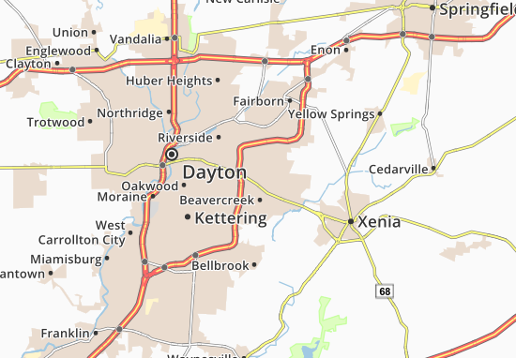
Next, I decided what locations throughout Dayton, Ohio that I was going to individually study. I wanted to get areas that had different ethnicities and classes, as well as geographical amenities, that provide social diversity. By doing this, I hope to give a more general and universal understanding of this issue while still covering a more compacted area. The ideas and findings that are revealed in this research process and paper can be seen throughout communities nationally and globally, meaning that they are relevant and useful for creating intentional and sustainable solutions to a plethora of emerging future issues. The chosen communities throughout the larger city of Dayton, Ohio are Beavercreek, Metro Dayton, Oakwood, and Trotwood. In these four areas I will be interviewing a resident or business employee with questions that address their current emotional state, background, sense of community, and perceived quality of life. This personal inquiry will enhance the research conducted about each individual community’s physical location, culture and ethnicity, and socioeconomic status.

Literature Review _______________________________________________________________

- Community: Identifying with the World Around You ___________________________
A theory referred to as Social Dominance Orientation (SDO) correlates personal feelings to the diversity of a community’s population. Similar to the research that I am conducting, a study entitled “Is the Racial Composition of Your Surroundings Associated with Your Levels of Social Dominance Orientation?” was conducted to shed light on the experience of minorities, especially African Americans, in a field of little to no prior research. The relevance of this research provided tangible evidence that my proposed theory is an actual issue that has yet to be managed. This study conducted by Radke et al. of four different groups of both the minority and majority populations were compared and contrasted with the number of ethnicities and social classes differing in each group to show how “outgroup dense environments” led to feelings of inferiority and decreased SDO (Radke et al., 11). The results were as follows:
“In line with this prediction, Study 1 found that minority group members who lived in environments that objectively had a high proportion of outgroup members reported lower levels of SDO. Moreover, minority group members (but not majority group members) who were surrounded by outgroup members reported lower SDO in Studies 2 and 3. In Study 4, Black Americans in outgroup dense environments perceived their group as having lower status compared to those in ingroup dense areas. Those who perceived their group as having lower status, in turn, were less likely to support hierarchical social structures” (Radke et al., 11).
It is very evident that certain ethnicities have more advantages than others on a national and global scale, but the way that this truth manifests goes beyond what is able to be clearly seen with the eye. For people in high-status groups, a socially dominant orientation is a way to maintain their influence and authority. SDO begins to categorize certain preferences that the majority of a population may have, such as endorsing politically conservative ideologies, holding prejudicial attitudes towards lower status groups, and endorsing hierarchy-enhancing practices and policies such as capital punishment (Radke et al., 2). SDO among someone who belongs to a group that is marginalized by the hierarchy, such as Asian Australians and Black Americans, has received less scholarly attention (Radke et al., 2). Below, Radke et al. speaks on some of the lived realities of minorities in a majority environment:
“Objectively, minority group members such as Black Americans exist in a social system in which they are disadvantaged by the hierarchy (e.g., in terms of wealth, education, and status). As such, it might be expected that SDO is chronically low in minority groups. However, this is not necessarily the case…Black Americans with a high level of SDO would not desire Black Americans to dominate White Americans, but rather would desire to maintain the extant hierarchical domination of Blacks by Whites, even at the ingroup’s expense,…We extend this argument to propose that despite the objective reality of the hierarchy, the environments in which minority group members are situated change the subjective experience of the hierarchy” (Radke et al., 2).
The acknowledgement that many of the routines and processes that have become “normal” to many started off as a way to link like causes together with the people most interested in them, reveals the natural and instinctive need to gather with those whom one feels comfortable with or can relate to. Since SDO embodies itself in minority communities as a relation their social context, intentional planning and development of these spaces are imperative for a positive response (Radke et al. 12). In many of these communities, self-identification and realization of power are key factors to their progression or demise. With the proper representation and ability to be educated about what is happening, as well as be included in decision-making processes, minorities can begin to feel seen in such a way that ignites teamwork, determination, and the resilience needed to aid in the bottom-up approach to urban development that creates more responsive and responsible communities.
There are many different ways that leadership can be defined and personified. In society and in organizations like the government and the military, it is common to see leadership as a way of control that utilizes the strengths and thoughts of a few people that are deemed experts or commanders. When their power is utilized, often there is no choice but to follow the mandated rules because stakes are generally high and require immediate action. Even though this leadership is can necessary when governing people, it is not always effective to and inclusive of everyone. Leadership that begins to look at what every person has to offer that is unique to their lived experience and skill sets will begin changing how people feel about themselves and behave on a daily basis (Schmitz).
Progressive change in minority spaces is absolutely necessary and attainable, but is much harder to achieve in the midst of prejudice, ignorance, fear, and pride. Some of these emotions create a divide between social classes and demographics, fueling a systematic cycle that breeds stagnancy for some of the community groups that desperately need change. To improve the design and planning of communities with such issues as this, there must be a holistic approach to change that starts at the bottom, for this portion of the population greatly defines the culture and stigma that often is associated with an area.
When conducting research for any subject, there must be someone advocating for minority communities and intentionally trying to be as ethical, inclusive, and knowledgeable as possible. If these measures are not put into place, it becomes extremely easy to disregard these groups of people, which in turn allows for some of the same patterns against inclusion to remain. More research must be conducted in an accurate and efficient manner, otherwise the data and the needs of these communities can be changed depending on who is conducting research. Ethical behavior must be evident throughout the entire research process to even begin communicating across ethnicities and diversities, showing the importance of the implementation processes of urban policies and regulations. Reiterating this point, Shore stated that “protecting the community and building community capacity to shape and conduct research are core objectives…as is educating academic researchers to increase their understanding and ability to engage diverse communities respectfully and ethically” (Shore, 1294). Ensuring that those managing minority communities are given the proper instructions and necessary training needed when dealing with live subjects, such as people, will allow for more authentic research to take place that make subjects and researchers feel empowered.

- Design and Planning: Preparing Communities for Success ________________________

Community, urban regeneration, and social psychology can operate simultaneously to give intentional insight on what factors may positively benefit a community and the people within it. Being able to identify with the people around you can be the beginning of creating a safe space where people will feel comfortable and understood. The relationship between place and psychological well-being can be, and is, influenced by the degree of interaction that a person feels they have in a community. In a study that analyzed different social dynamics that could influence self-identification within communities, tests on different groups of people were conducted via questionnaire, such as pregnant women or foreign exchange students in their host country, to determine certain group’s circumstantial needs (Heath). This method also strengthens the idea that direct interaction with people about lived experiences is most important for research.
Top-down and bottom-up approaches to social order often highlight what methods are more beneficial for inclusive community building, versus what methods are looked down upon by certain ethnicities and social classes. A top-down approach, such as gentrifying a poor area with a middle-class and “more affluent” population, ultimately changes the systematic and physical culture of those spaces and requires very little to no communication with previous community-dwellers, solely relying on the “expertise” of outside regulators and spectators (Heath, 855-856). Efforts such as this were initiated to offset possible problems created by and fueling poverty in cities, but like many other similar programs this also highlighted issues that have yet to be addressed in social contexts. For example, gentrification has been criticized about its failure to reduce the inequality between the poorest and the richest, as well as the suggestion that taking such a top-down approach to regeneration undermines the sense of self-worth among the original community members (Heath, 856).
Contrasting this idea, a bottom-up approach relies heavily on community involvement, intentionality, and personal responsibility for a proposal or policy’s outcome and implementation in the long run. This method aligns with the intent behind my research, emphasizing the importance of recognizing and utilizing all of a community’s assets, even when they exist in the poor and minority communities. Beginning to change how these groups of people are perceived and accounted for is the first step in making changes that will be accurate and inclusive, therefore improving the response from these communities. A sense of belonging and identiﬁcation with groups is associated with willingness to pay back to these groups and contribute to their goals, so applying this insight to urban regeneration suggests that community identiﬁcation may be an important benefactor of community involvement and participation that will lead to more sustainable and positive change (Heath, 858).
For many years, poor and minority populations have fallen victim to prejudices that can be seen as an excuse to be overlooked when efforts of urbanization occur. When expanding on this issue in the urban planning field, urban planning professor Lisa Bates stated that, “White people do great in racially concentrated areas...they’re living it up. It’s not predominantly black neighborhoods themselves that cause problems for their residents. It’s the way our society and government treats those neighborhoods that causes harm…The problem is racism…and that…is the real challenge that needs to be addressed…Our entire urban history has been about moving people to solve problems…We only try to make people move…when they’re poor and people of color.”
Recognizing that less than ten percent of the American Planning Association’s members were racial minorities, compared to over thirty percent of the U.S. population being considered a minority, shows the stark underrepresentation of these people that eliminates them from many conversations and decisions that directly impact their daily lives (Holeywell). Another urban planning professor at the University of Michigan seconds this argument suggesting that what is perceived as normal today is merely the final result of privilege that has been accumulating since the 1920s, with injustice becoming so engraved into society that many members of the social majority do not recognize it (Holeywell).
Nasser’s 2015 article examining that ways that urban planning, architecture, community advocation, and design have shaped some of the negative realities plaguing many current minority populations emphasizes some of the struggles that have been faced between minorities and the police in the United States. Tragedies that were alluded to, ranging from racial profiling to senseless murder, reveal how city design has not been geared toward addressing some of the social inequities continuing to hinder many poor, urban, African American communities nationally. The debate over architecture’s role in promoting social justice is not a new concept. In fact, during the civil rights movement backlash against “urban renewal” and massive housing projects sparked a grassroots community design movement, but the efforts were spotty and rarely involved broad involvement from investors, city planners, architects and designers (Nasser). The idea that community plays a large role in its management and maintenance is found to be common in minority spaces, but usually is resulting from a lack of other resources or inclusion in other systems. With improved systematic planning and a change of values when dealing with these vulnerable populations, positive improvements can be made that will benefit communities holistically.
When defining what a good neighborhood is and what it offers, often times there is little consideration for the actual people living in communities, while the emphasis is placed on creating a specific image for outsiders to marvel upon or for the affluent to experience. When speaking on what constitutes as a “good neighborhood” it was said that, “There is little disagreement that spaces with good housing, parks, clean streets, public transportation and good schools can lift neighborhoods out of squalor…It’s the creation of the kinds of spaces that basically recognize the dignity of life and respect different communities…If you have a decent living environment, it does make a difference. … It has deep impacts in terms of how you feel, how you behave and how you socialize. Space leads to separation and to segregation (Nasser)”.
Planners and designers are responsible for creating spaces that address the needs of the people utilizing them, while simultaneously allowing natural and built environments to engage living things and be fully experienced. For this to become the norm, a combination of creativity, positive progression, and the incorporation of social responsibility into decision making processes must start being mandated. Only by knowing the community you serve, as well as their wants and needs, can systems be made to correctly represent them.

- Quality of Life- Perceived Experience _______________________________________

Discrimination, or what is perceived as such, can negatively affect people on emotional levels that may not always be considered. By approaching an individual’s daily experience and unique stressors that possibly impact how they feel about themselves, an accurate assessment of how discrimination affects them can be made with that person’s specific ideas and opinions in mind. Neglecting this aspect of social interaction can fail to measure stress comprehensively and can underestimate its negative contribution to health (Williams et al. 113). Conducting research that analyzed how discrimination impacts a group of Americans and South Africans through a series of questions, levels of self-esteem were found to be drastically different among them. African Americans were found to be more confident than South Africans in social contexts, while both groups admitted experiencing some form of discrimination and lacking effective resources (Williams et al.). Realities such as this were said to begin having negative effects on health overtime, with discrimination manifesting into a hesitance to be involved within the community or perceiving most actions from other groups of people as discriminatory, therefore assuming further and fueling a vicious cycle.
In America, the majority of the population is considered Caucasian, while in South Africa over seventy-five percent of citizens are of ethnic majority. These stark cultural differences reveal how the demographics of the two areas differ greatly, and because of that show how important it is to constantly learn about different cultures and how geography or setting helps to shape personalities. Adaptive measures correlating the foundation of what communities believe in or how they are impacted by social systems in place can begin to speak on how humans are directly drawn to nature or possess common desires to be connected, nourished, and taken care of. The importance of these ideas was iterated in this statement:
“Research is needed to understand the contexts in which discriminatory experiences occur and how the environment shapes the nature and levels of discrimination, the willingness of various social status groups to report them and the measurement strategies needed to accurately capture them. Future research should also give attention to the potential of cross-national and racial variations in the determinants of self-esteem. For example, the self-esteem of Blacks in the USA is more based on ‘God’s love ’ than that of Whites… Future research should explore variation in ideologies across contexts for racially disadvantaged groups and identify the extent to which such beliefs may moderate the association between discrimination and self-esteem and mastery” ( Williams et al., 130).
From this perspective, there are many possible factors that influence self-esteem that are not considered, many being the relationships that people have amongst each other and in their communities. The topic of faith being a driving force of self-esteem was interesting because it reveals the trend of minority groups of being very invested in organizations and/or causes that provide a sense of identity and personal strength. When addressing minority communities, it is important to keep the relational factors a priority so that their needs will be met in a way that is best suiting for them. Extra efforts for inclusion as such can begin showing these areas empathy, care, and understanding that can improve some of the negative systematic routines that may be present.
Natural aspects are directly related to human mood and temperament. Outside of being imperative for life and health overall, nature exposure and greenery have been found to be very influential to the fields of urban planning and design. Natural elements, such as actual plants or animals, are said to be essential for many healing and wellness aspects that people need in order to function (Largo-Wight, 43). This design scheme is used often in healthcare facilities for this reasoning, but I would make the argument that residential areas are a space for familial healing and need the same amount of care and attention to detail, if not more, for in these spaces live many of the people that drive local markets which are imperative to the economy.
The degree of natural exposure was explained in three separate categories (Largo-Wight, 43-56):
- Outdoor- Direct exposure and most concentrated health benefits.
- Indoor- Natural aspects like plants, natural lighting, aquariums, and other animal contact indoors (therapy/service animals).
- Indirect Nature Contact- Pictures, sounds, or replicas of nature and animals in setting.

Each option allows for a deeper level of interaction with nature that all have beneficial effects on people. The research suggested that public health professionals collaborate with healthcare and policy professionals, design-related professionals, and urban planners to apply these ﬁndings and promote healthy environments that may begin to cultivate grounds for viewing and experience, maintain healing gardens and promote gardening, incorporate wooded parks and green space in communities and urban settings, and much more (Largo-Wight, 57). Again, diversity and collaboration are driving forces that can start to bring about changes within the development of cities and communities. Considering this aspect of design can drastically impact social productivity and health for the better, in turn creating healthier communities.

Methods _____________________________________________________________________

I researched statistics and scholarly information, as well as received personal opinion, to find out how community design and planning impacts those living in them, focusing on minorities and working classes. The Wright State database, online articles, book excerpts, and personal inquiry were used to gain outside information for my project. The preexisting sources provide what is already known about this topic, while the personal interviews allowed me to gain a perspective that is directly influenced by a variety of factors dependent on the specific day that I questioned them. To determine this, I asked the four employees and residents of different communities throughout Dayton, Ohio ten questions about community, upbringing, overall quality of life, and present-day emotion. The intent behind this method was to help improve my skills when speaking with people and feel more comfortable asking community members about their insight and opinions. Also, I initially wanted to see what the physical patterns of the communities were like because a lot can be discovered solely by observation.
Before conducting interviews, each participant read, agreed to, and signed a consent form that explained who I am, what the premise of my research is, and grants my permission to use their response and/or name in the formation of my research. Since I intentionally asked different types of people about their insight and opinions, I wrote general questions that allowed for unbiased answers that further explained their personal opinion and/or experience. For short answer responses the results were placed in a table format to be most easily understood. All responses were typed in the format of the survey for each individual community member.

After my attempts at receiving random input had to be adjusted, I requested volunteers via social media, Facebook, to see if anyone would be willing to be a part of my research. From that request a person got in contact with me and was willing to help, and the interviewee from Trotwood ended up being one of volunteers. For the remaining three interviews, I reached out to people that I knew personally that varied in age and life experiences, as well as where they lived in Dayton.

Results of Research ____________________________________________________________

- Beavercreek, Ohio

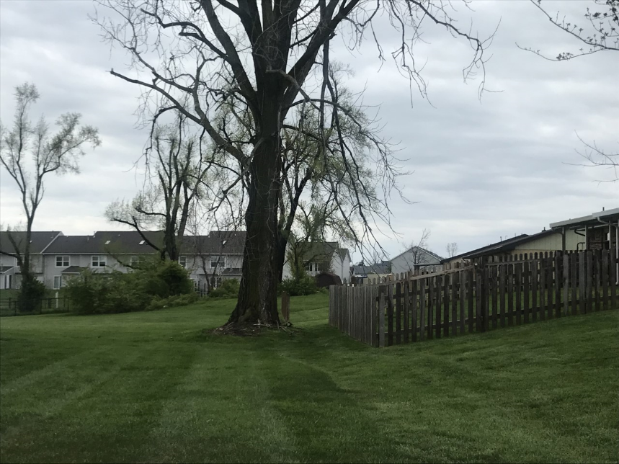

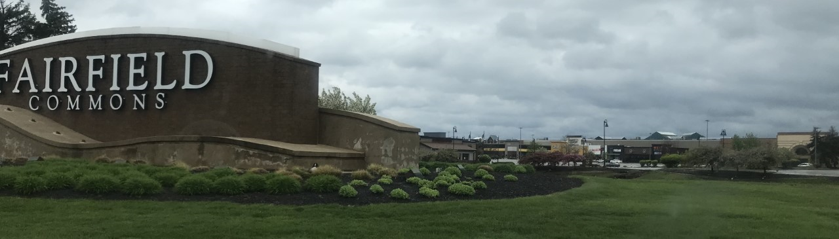

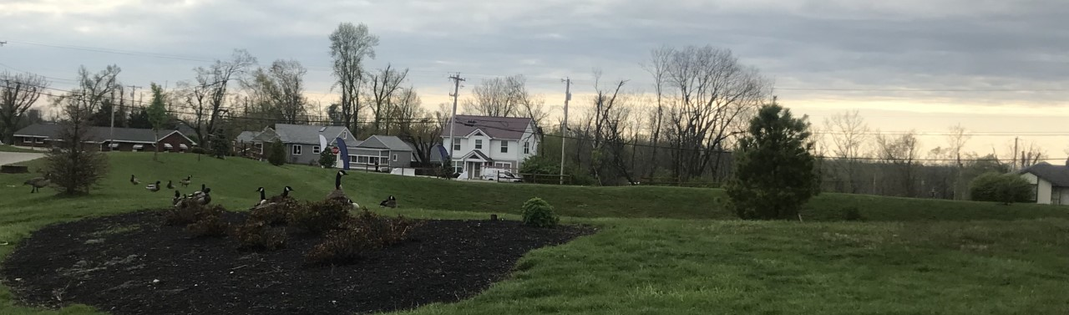

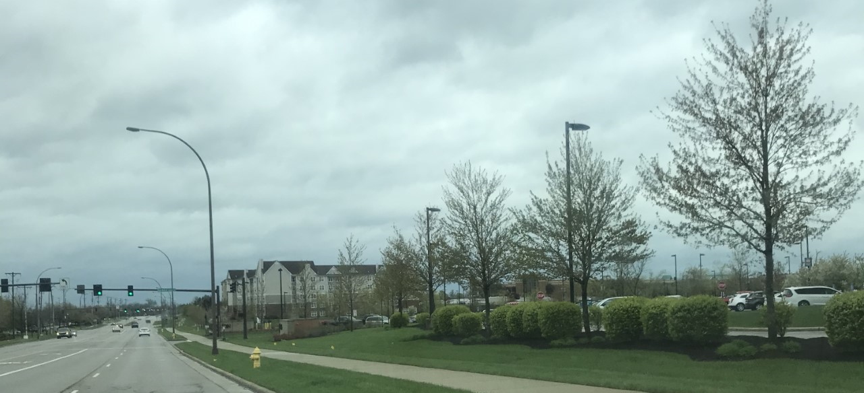

- 87.8% Caucasian, Asian, Mixed Race, African American, Other, Native/Indian (in order of greatest to least amount)
- Median household income: $88,456
- Assets: Near military base, shopping malls/entertainment options,
- Personal Inquiry: Tony Moore, Videographer for WPAFB and as a freelancer

- How are you feeling today?
Good. On quarantine, bored. Adjusting to everything that is happening at the moment

- How do you classify yourself ethnically/culturally?
(intended answer: African American, Hispanic, Caucasian etc.)
Black American.

- Where did you grow up/how was your upbringing?
Lived around the world, military kid and continued to work in the field/similar travel patterns

- What is your socioeconomic status? (Looking for: Financial status in terms of numbers)
Middle class

- Do you feel as if your needs are met within close proximity to where you live? Yes or no, and then further specify.
  - Less than 5 miles
  - 5-7 miles
  - 7-10 miles
  - 10+ miles
- How close do you live to your place of employment? Please select an option below:
  - Less than or equal to 5 miles
  - Between 5-10 miles
  - 10+ miles
- What does community mean and look like to you? / How would you define community?
A place where diversity is present and thriving, having their own dollar and lifestyle that is effective for their individual culture.

- Do you notice the buildings, organization, and natural elements within your community? Yes or no, and then feel free to further explain.
No not really, being from a big city with a lot to do there is a stark difference in what is offered.

- In order of personal importance, how would you rate the following with the first being the most important and the last being the least important?

- Natural Lighting- 1
- Interactive Spaces (varying textures and/or levels of spatial experience)- 3
- Greenery and/or Natural Elements- 2
- Ambient Noise- 4

- Would you like to see any change within your community? If so, what?
Less pollution and littering, more plant life and less structure. More freedom of choice. Activities, very important.

- Dayton, Ohio

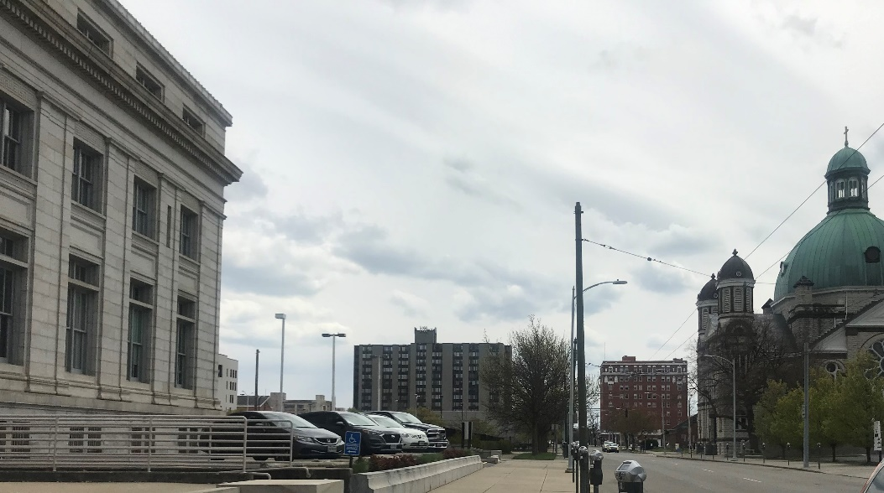
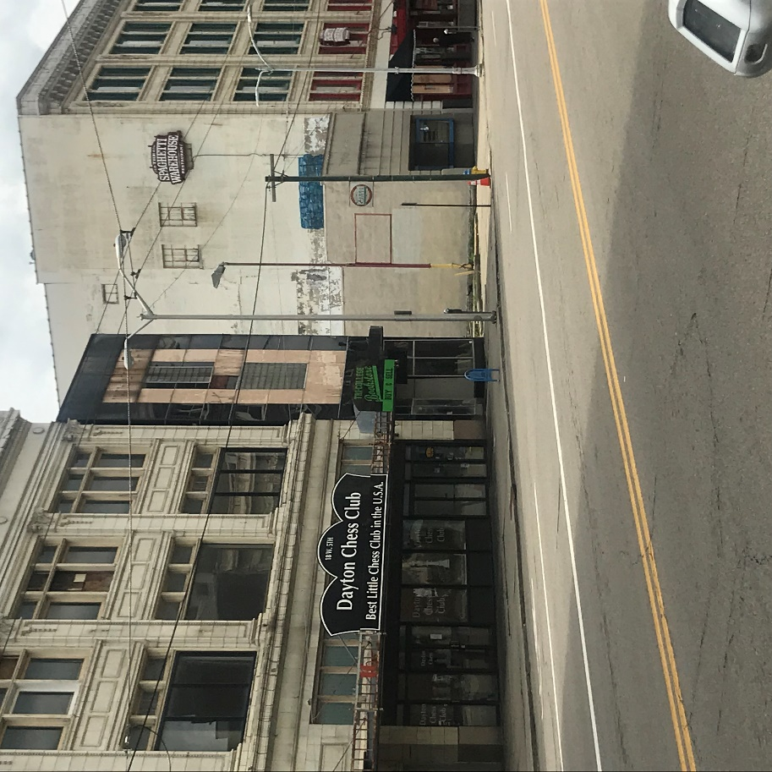
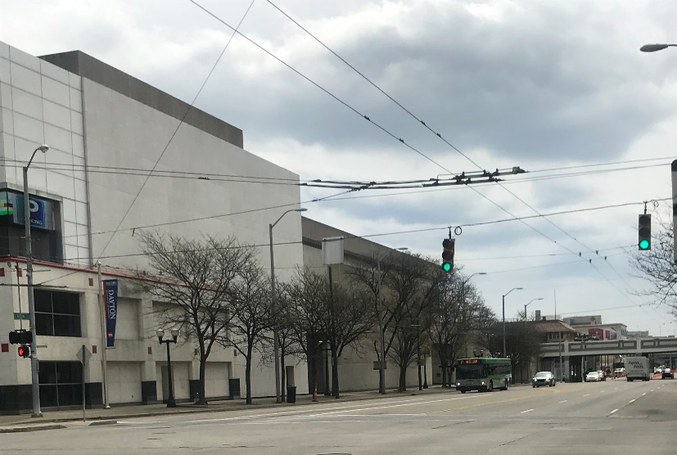
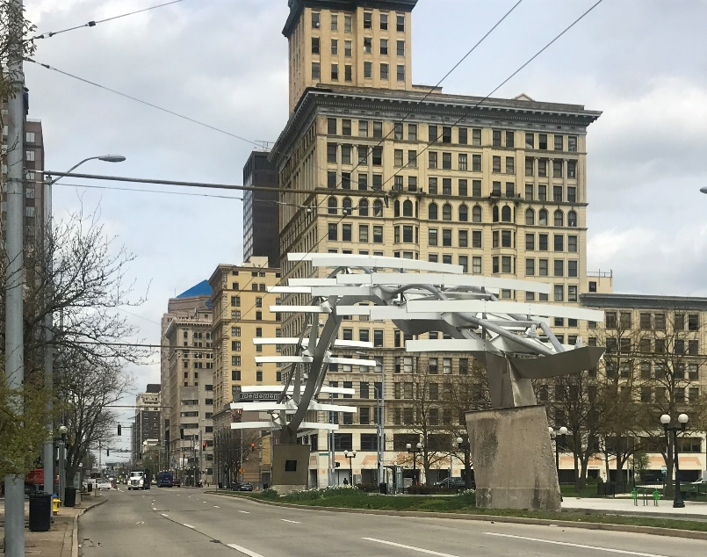
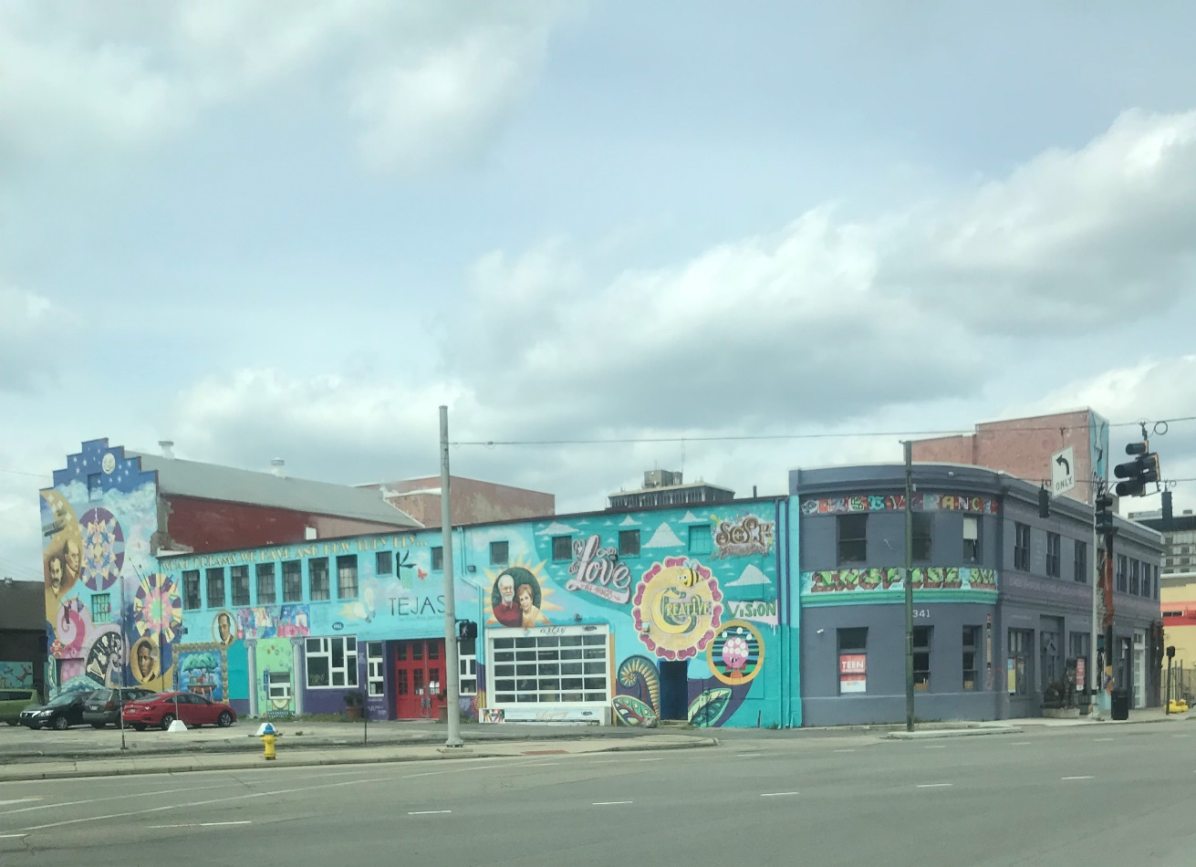
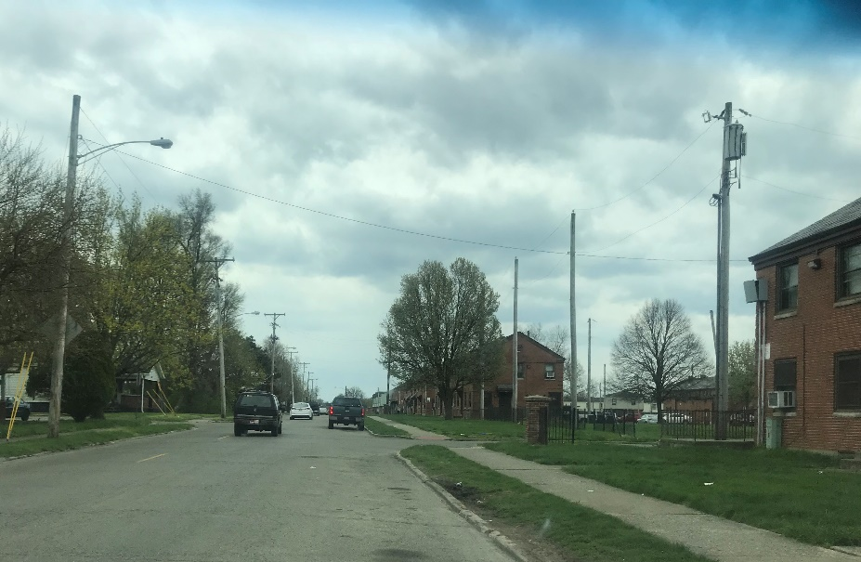
- 52.6% Caucasian, 38.9% African American, 3.95% Latino, Asian, Indian/Native, Other
- Median Household Income: $30,128
- Assets: Has multiple universities/schools and corporations near downtown. Near water and has highway systems
- Personal Inquiry: Gwendolyn Reynolds, Coordinator and Supervisor at Public Health and Health Services
- How are you feeling today?
Good!
- How do you classify yourself ethnically/culturally?
(intended answer: African American, Hispanic, Caucasian etc.)
African American

- Where did you grow up/how was your upbringing?
Trotwood, Ohio. Dual-parent household, married and both employed. Siblings, one brother and sister. Low income housing, but big on family and very creative/inventive family from cooking to fashion. Never on welfare.

- What is your socioeconomic status? (Looking for: Financial status in terms of numbers)
Low/middle class. $58,000/year.

- Do you feel as if your needs are met within close proximity to where you live? Yes or no, and then further specify.
- Less than 5 miles
- 5-7 miles
- 7-10 miles
- 10+ miles
- How close do you live to your place of employment? Please select an option below:
- Less than or equal to 5 miles
- Between 5-10 miles
- 10+ miles
- What does community mean and look like to you? / How would you define community?
A place that is filled with necessary resources (food, gas, shelter, food pantries, daycare, hospitals, nursing homes, etc.). People have what they need close to them. Many things and people mingling about a smaller area.

- Do you notice the buildings, organization, and natural elements within your community? Yes or no, and then feel free to further explain.
Yes, I notice it. The buildings are very rundown and need to either by updated or demolished, and the land repurposed for positive use. Roads need attention, lead to other costs and issues of transportation. Landscape work needs to be completed for trees and parks. Community has to change their habits and respect for the area, some people are “unaware of their actions”, all leading to the depletion of goods and mindsets. If people do not feel connected to their physical spaces or lack power (or the feeling to make change) they seem to feel less responsible for what happens there. Responsibility and accountability are lacking.

- In order of personal importance, how would you rate the following with the first being the most important and the last being the least important? (c, a, b, d)
- Natural Lighting- 2
- Interactive Spaces (varying textures and/or levels of spatial experience)- 3
- Greenery and/or Natural Elements- 1
- Ambient Noise- 4

- Would you like to see any change within your community? If so, what?
Yes.
- Only 1 grocery store, Siebenthaler Rd., and no hospital (Good Samaritan Hospital recently closed and being torn down)
- Competition for basic resources, forcing travel for more diverse and better options
- Other, more affluent neighborhoods, have needs and many wants met
- Dayton has little to no jobs and other resources. No formal restaurants, all fast-food and small businesses.
- More investing in housing and infrastructure
- Taxpayers deserve for their dollars to be put to good use
- Incentivize places, such as the mall, to seem like it is a “treat” or something that cannot and should not happen often.
- The importance of travelling and seeing the world for reasonings of expansion, exposure, and understanding of self and the world. Needing to be challenged, as well as encouraged. Supplying hope and realistic goals for minority/poor populations
- People in power need to be about that action! Also though, communities need to play their role and do their part. Whatever that may be! Education and action that will enable and unleash hidden leaders. Tap into individual specialties and apply that* the need for different assets and goal sets.
- “Phoenix Project”- grants given to some homeowners close to Good Sam to improve the look and appear to be investing in the community. Only a few received this and actually had to make a substantial amount of money. She did not qualify when she actually needed it and lived close to the hospital, but not in eyesight.
- Resources HAVE to be there in the short and long term. There has to be a holistic study that understands the daily lives and struggles of people/audience that is being studied or adhered to. (Ex: RTA catering to A/A communities because it is assumed that there are less car owners. Alluding to RTA stops in Beavercreek and the issues arising from that).

